
FRESH TEACHER'S E-LIBRARY
BEGINNING OF TERM III EXAMINATION 2023
PRIMARY ONE
ENGLISH

My name is ______________________________________________

I am in __________________________________________________

My school is _____________________________________________
SECTION A:
- Name these pictures.
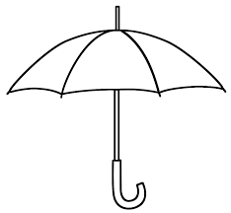 | 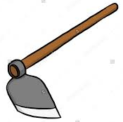
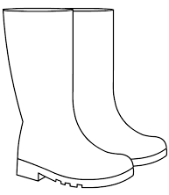
- Complete the structures correctly.
Are these gumboots?
_________________________________________
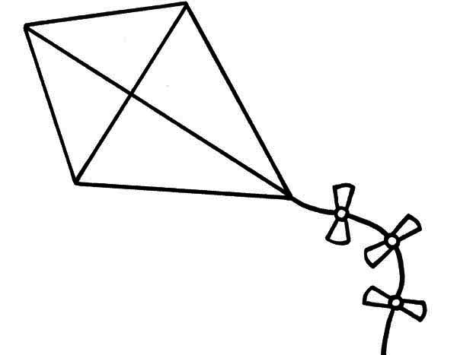
What is this?
__________________________________________
- Arrange the words in ABC order.
- windy, cloudy, sunny, rainy
_______________________________________________________
- vest, van, vehicle, vase
_______________________________________________________
- Fill in with “a” or “an” to complete the sentences.
- Mary eats _____________apple every day.
- The teacher is using ____________pen to write in my book.
- We use ____________umbrella on a rainy day.
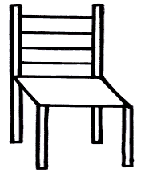
- Use ‘in’, ‘under’, ‘on’, or ‘near’ to fill in the gaps.
- The ball is ____________the chair.


- The flower is __________the pot.
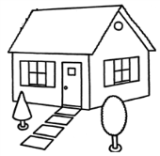
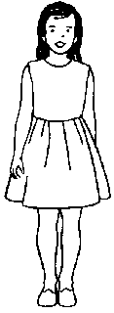
- The girl is standing ___________the
house.

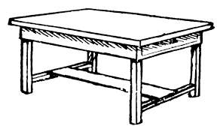
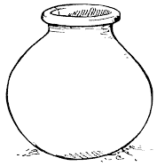
- The pot is ____________the table.

SECTION B
- Read the story and answer the questions in full
sentences.
Musa lives with his parents in Buloba village. His father is a carpenter. He makes nice chairs, tables and beds. Every Saturday, Musa goes with his father to the workshop. Musa’s mother is a nurse. She takes care of sick people.
Musa’s father buys food at home and pays school fees for Musa. The mother cooks food and cleans the house every morning. They are in a happy family.
Questions
- Who is the boy in the story?
_______________________________________________________
- Where does Musa live?
_______________________________________________________
- What does Musa’s father make?
_______________________________________________________
- How many people are in the story?
_______________________________________________________
- When does Musa go to the workshop?
_______________________________________________________
- Re – arrange these sentences to form a correct story.
- He ran to the shop.
- He asked his father for money.
- John wanted to buy a book.
- And bought the book.
- His father gave him the money.

- _______________________________________________________
- _______________________________________________________
- _______________________________________________________
- _______________________________________________________
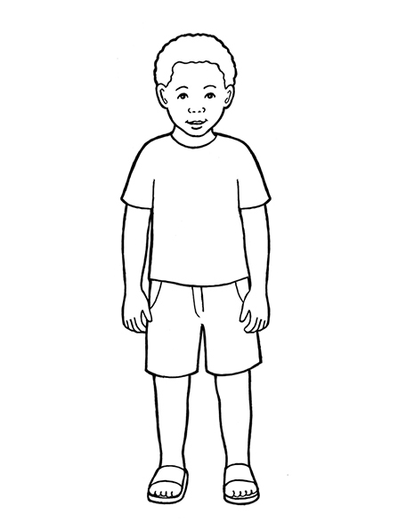
- _______________________________________________________
- Complete the story.
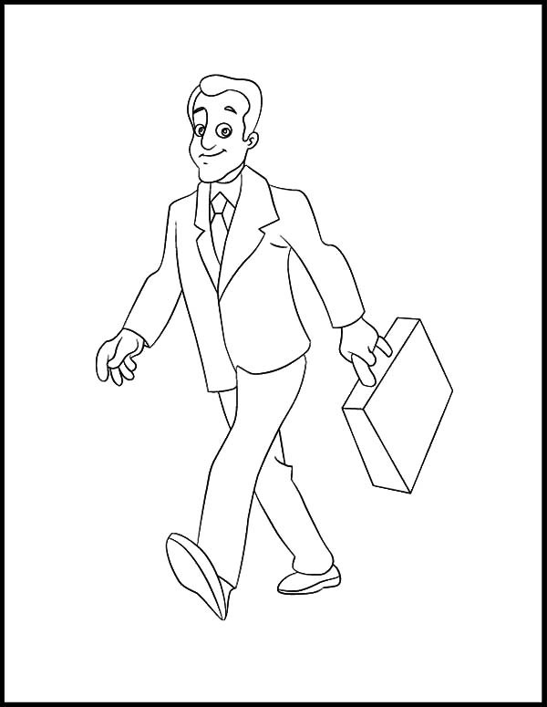
One day a, ________was walking with a _________
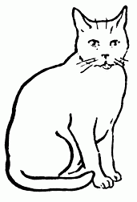

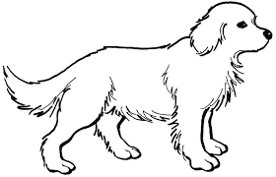
to town. On the way, they met a ____________

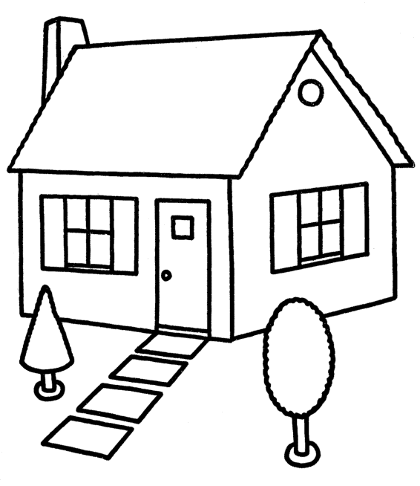
and a _______________. The dog

wanted to bite the boy. The boy ran into the

_________________which was near the road.

- Read the conversation and answer the question
Correctly.
Peter: Good morning, Pam.
Pam: Good morning, Peter.
Peter: Where are you going?
Pam: I am going to the shop to buy sunglasses.
Peter: What are the sunglasses for?
Pam: The sunglasses are for protecting my eyes from too much sunshine.
Peter: I will ask mother to buy them for me too.
Questions
1 ________________and ______________are talking in the conversation.
2. Who talked first?
_________________________________________________
_________________________________________________
3. Where is Pam going?
_________________________________________________
_________________________________________________
4. Sunglasses protect us from too much ______________.
- Make four correct sentences from the table.
She  I  Peter and Jane  We | do  does | very neat work.  homework every day.  not like playing in class.  not eat lemons.

(a)_________________________________________________________
(b) ________________________________________________________
(c) ________________________________________________________
(d) ________________________________________________________
END

